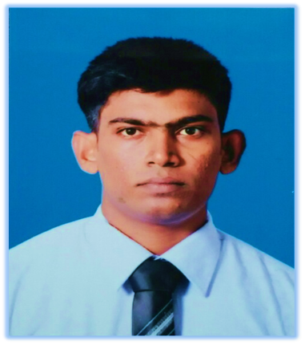**CURRICULAM VITAE**

**Mr.ARUNTHAVANATHAN JATHUSAN**

No 13, Greenland Mawattha, Nedimala, Dehiwala.

Mobile Number: 0772936955

E-mail Address: yathusan1991@yahoo.com

**CAREER OBJECTIVE**

Looking for an organization where I can enhance my knowledge and from my academic learning give my best to the organization and seeking a challenging position where I could grow and contribute in an organization to meet organization objects as well as my goals.

**PERSONAL DATA**

Name with Initial: A.Jathusan

Date of Birth: September 16, 1991

Age: 24

Gender: Male

Civil Status: Single

Nationality: Srilankan

N.I.C.No.: 912602125V

**EDUCATIONAL QUALIFICATION**

University : 2012 to 2016

Business Management

Undergraduate (BBM)

Vavuniya Campus of the University of Jaffna.

G.C.E Advanced Level : 2010 Index No: 6542506

Examination Economics A

Accounting B

Business Studies B

General Knowledge 65

G.C.E.Ordinary Level Examination : 2007 Index No: 74909282

Hinduism ATamil Language A

Social BHealth Science B

Agriculture B English C

Science & Technology CMathematics C

Art S Tamil Literature S

**PROFESSIONAL QUALIFICATIONS**

Successfully completed Diploma in PC Application and Office Management course at Information Technology Park, Jaffna, Sri Lanka in 2010.

Successfully completed The Certificate in Banking and Finance at the Institute of Bankers of Srilanka in march 2013.

Successfully completed the Diploma in Banking and Finance at the Institute of Bankers of Srilanka from 2014.

**EXTRACURRICULAR ACTIVITIES**

Captain of School and University Cricket team.

Won prizes in School, Zonal and Provincial level Elle and Cricket tournaments.

Won prizes for badminton, table tennis, football, volleyball and cricket at university.

Participated in the English Day and Tamil Day Dramas.

Member of College Hindu union.

**SKILLS & ATTRIBUTES**

*Leadership Skills*

Participated in three week Leadership Training and Positive Thinking Development Programme conducted at National Cadet Corps Training enter from 11th July 2011 to 31st July 2011 on the instructions of Ministry of Defense in Collaboration with Ministry of Higher Education.

*Communication Skills*

Excellent communication skill in English, Sinhala& Tamil languages.

**CHARACTER REFERENCES**

**Dr.A. Pushpanathan Dr. T. Mangaleswaran**

Dean, Senior Lecturer,  
Faulty of Business Studies, Dept. of Economics and Management,  
Vavuniya Campus, Faculty of Business Studies,  
University of Jaffna. Vavuniya Campus.

Contact no: 0243248188 Contact no: 0243248188

0776527894 0714347689

I declare that the above mentioned information is true up to my knowledge and belief. I assure I will be loyal to firm and do my duties sincerely.

**ArunthavanathanJathusan**

Applicant.